**User Stories & Planning Poker**

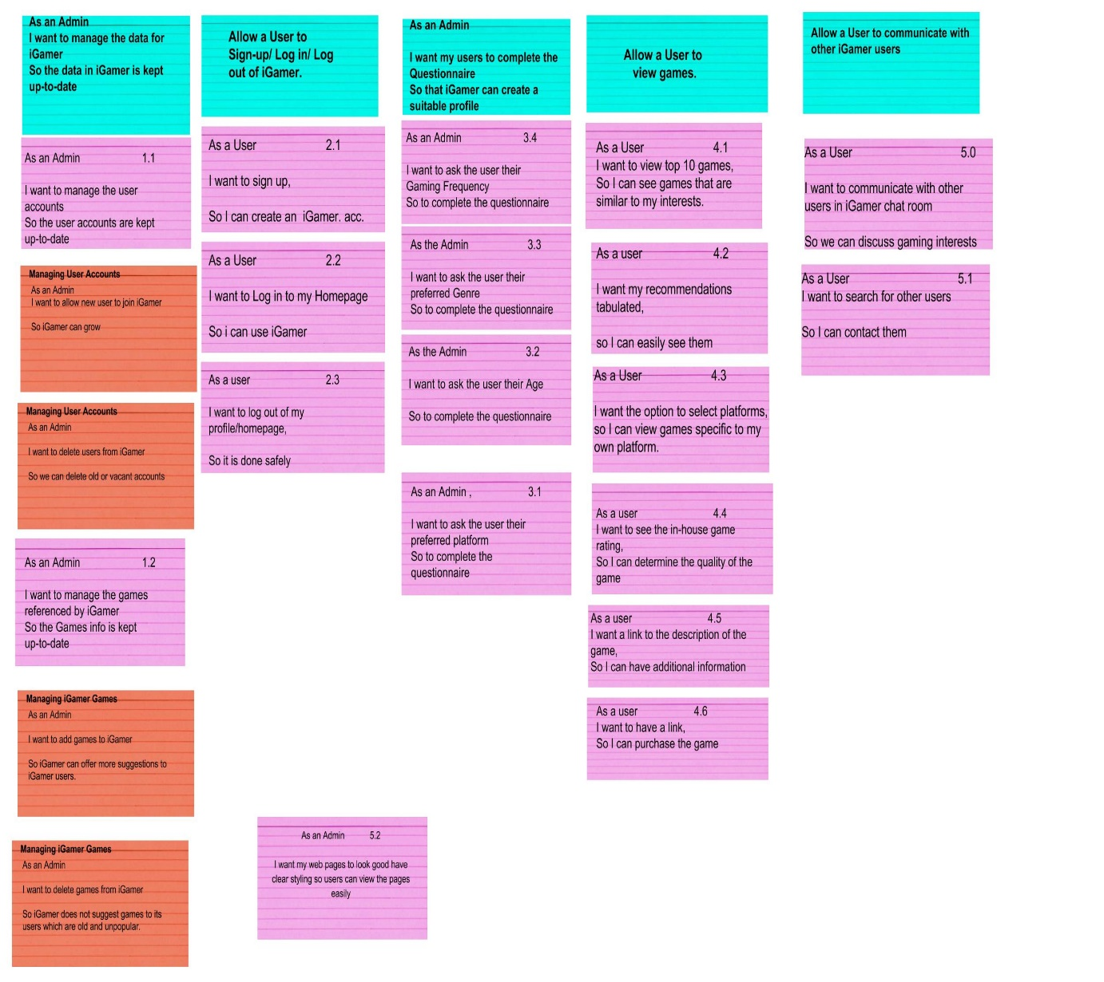

**iGamer Planning Poker**

|  |  |  |  |  |  |  |
| --- | --- | --- | --- | --- | --- | --- |
| User Story Number | Group Member Estimates | | | | | Average Estimates |
|  | Stephen  Buckley | John Cheasty | Gary  Crowe | Alan Geraghty | Martin Healey |  |
| 1.1 | 13 | 13 | 15 | 15 | 15 | 14 |
| 1.2 | 5 | 8 | 6 | 8 | 10 | 7.5 |
| 2.1 | 5 | 7 | 5 | 7 | 5 | 5.9 |
| 2.2 | 4 | 6 | 6 | 7 | 5 | 5.6 |
| 2.3 | 6 | 6 | 7 | 5 | 4 | 5.6 |
| 3.1 | 1 | 1 | 3 | 2 | 3 | 2 |
| 3.2 | 1 | 1 | 2 | 3 | 2 | 1.8 |
| 3.3 | 2 | 2 | 4 | 2 | 2 | 3.2 |
| 3.4 | 1 | 1 | 3 | 4 | 3 | 2.4 |
| 4.1 | 10 | 9 | 10 | 8 | 9 | 9.2 |
| 4.2 | 3 | 2 | 4 | 4 | 3 | 3.2 |
| 4.3 | 4 | 3 | 3 | 2 | 2 | 2.8 |
| 4.4 | 2 | 2 | 1 | 2 | 1 | 1.6 |
| 4.5 | 1 | 1 | 2 | 2 | 2 | 1.6 |
| 4.6 | 2 | 2 | 1 | 2 | 1 | 1.6 |
| 5.1 | 19 | 22 | 18 | 20 | 22 | 20.2 |
| 5.2 | 6 | 6 | 7 | 5 | 4 | 5.6 |
| Total Programming Hours |  |  |  |  |  | 102.2 |

Estimate times are in Units of Programming Hours

1 Programming Hour = 60 min.